UNIVERSIDAD POLITÉCNICA DE YUCATÁN



EMBEDDED SYSTEMS ENGINEERING 3A

ADVANCED PROGRAMMING

HOMEWORK 1. SOFTWARE DEVELOPMENT LIFE CYCLE

PROFESSOR. LUIS CAMARA

STUDENT: RODRIGO ADRIAN OROZCO OLGUIN

DUE DATE: 10/09/2021

**Flipped Learning**

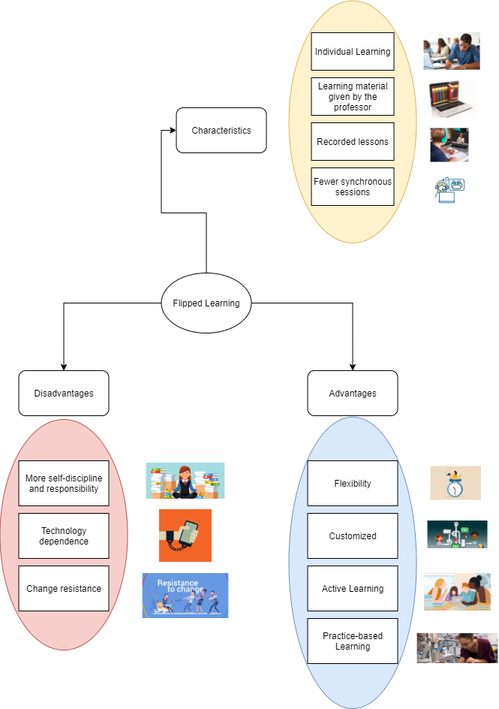

**Software Development Life Cycle (SDLC)**

Software Development Life Cycle is the application of standard business practices to building software applications. SDLC is a way to measure and improve the development process. It allows a fine-grain analysis of each step of the process. This, in turn, helps companies maximize efficiency at each stage. As computing power increases, it places a higher demand on software and developers. Companies must reduce costs, deliver software faster, and meet or exceed their customers’ needs. SDLC helps achieve these goals by identifying inefficiencies and higher costs and fixing them to run smoothly.

The Software Development Life Cycle simply outlines each task required to put together a software application. This helps to reduce waste and increase the efficiency of the development process. Monitoring also ensures the project stays on track, and continues to be a feasible investment for the company.

**Requirement Gathering and Analysis**

During this phase, all the relevant information is collected from the customer to develop a product as per their expectation. Any ambiguities must be resolved in this phase only.

Business analyst and Project Manager set up a meeting with the customer to gather all the information like what the customer wants to build, who will be the end-user, what is the purpose of the product. Before building a product a core understanding or knowledge of the product is very important.

Once the requirement gathering is done, an analysis is done to check the feasibility of the development of a product. In case of any ambiguity, a call is set up for further discussion.

Once the requirement is clearly understood, the SRS (Software Requirement Specification) document is created. This document should be thoroughly understood by the developers and also should be reviewed by the customer for future reference.

**Design**

In this phase, the requirement gathered in the SRS document is used as an input and software architecture that is used for implementing system development is derived.

**Implementation or Coding**

Implementation/Coding starts once the developer gets the Design document. The Software design is translated into source code. All the components of the software are implemented in this phase.

**Testing**

Testing starts once the coding is complete and the modules are released for testing. In this phase, the developed software is tested thoroughly and any defects found are assigned to developers to get them fixed.

Retesting, regression testing is done until the point at which the software is as per the customer’s expectation. Testers refer SRS document to make sure that the software is as per the customer’s standard.

**Deployment**

Once the product is tested, it is deployed in the production environment or first **UAT** (User Acceptance testing) is done depending on the customer expectation.

In the case of UAT, a replica of the production environment is created and the customer along with the developers does the testing. If the customer finds the application as expected, then sign off is provided by the customer to go live.

**Maintenance**

After the deployment of a product on the production environment, maintenance of the product i.e. if any issue comes up and needs to be fixed or any enhancement is to be done is taken care by the developers.

**Importance of SDLC**

When we are working in the development of any software, it is important to follow certain steps in order to fulfill the client’s specifications and expectations. In this aspect, the steps described in SDLC are the main guide to follow; since it enhance the comunication between the client and the project manager, it ensures that the software fulfill the expectations. Moreover, with the design and implementation steps, we create the software in the best way to achieve the development of the software without any issue. However, some issues can take part of the process and it is necessary fix them through testing step and give it maintenance for the rest of the life of the software.

Github repository link: [rodrigo-orozco/advanced_programming: Repository of Advanced Programming Course (github.com)](https://github.com/rodrigo-orozco/advanced_programming)

**References**

Jevtic, G. (2021, February 10). *What is SDLC? Phases of Software Development, Models, & Best Practices*. PhoenixNAP Blog. https://phoenixnap.com/blog/software-development-life-cycle

Lms, E. (2020, August 5). *Ventajas y desventajas del aula invertida en el entrenamiento corporativo | Easy LMS*. EasyLMS. https://www.easy-lms.com/es/centro-de-conocimiento/acerca-de-aula-invertida/aula-invertida-ventajas-desventajas/item10610

*What Is SDLC (Software Development Life Cycle) Phases & Process*. (2021, August 27). Software Testing Help. https://www.softwaretestinghelp.com/software-development-life-cycle-sdlc/#SDLC_Phases